# Ipsec jednoducho

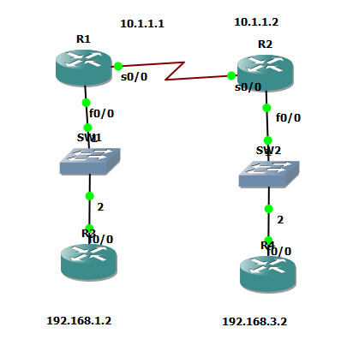

# R1

crypto isakmp policy 10

authentication pre-share

crypto isakmp key heslo address 10.1.1.2

!

crypto ipsec transform-set PIATOK esp-aes esp-sha-hmac

!

crypto map MAPA 10 ipsec-isakmp

set peer 10.1.1.2

set transform-set PIATOK

match address 100

!

interface FastEthernet0/0

ip address 192.168.1.1 255.255.255.0

!

interface Serial0/0

ip address 10.1.1.1 255.0.0.0

clock rate 64000

crypto map MAPA

!

ip route 192.168.3.0 255.255.255.0 10.1.1.2

access-list 100 permit ip 192.168.1.0 0.0.0.255 192.168.3.0 0.0.0.255

# R2

crypto isakmp policy 10

authentication pre-share

crypto isakmp key heslo address 10.1.1.1

!

!

crypto ipsec transform-set PIATOK esp-aes esp-sha-hmac

!

crypto map MAPA 10 ipsec-isakmp

set peer 10.1.1.1

set transform-set PIATOK

match address 100

!

interface FastEthernet0/0

ip address 192.168.3.1 255.255.255.0

!

interface Serial0/0

ip address 10.1.1.2 255.0.0.0

clock rate 2000000

crypto map MAPA

!

ip route 192.168.1.0 255.255.255.0 10.1.1.1

!

access-list 100 permit ip 192.168.3.0 0.0.0.255 192.168.1.0 0.0.0.255